- Extract 3 files.
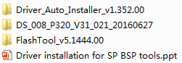

- Please read this file carefully, and install the USB drivers according the ppt file.
- After install USB drivers successful, open
And click
- Click options button
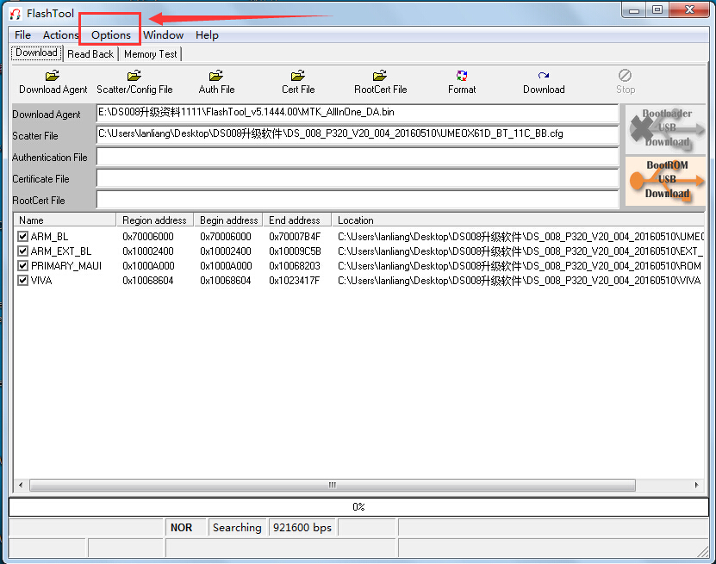
5.Choice like the following pictures
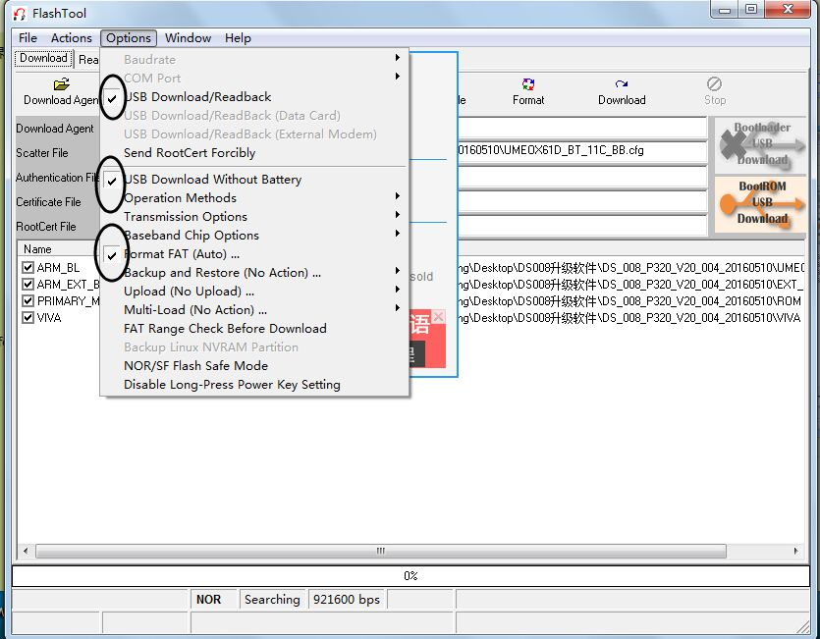
6.click scatter/Config File
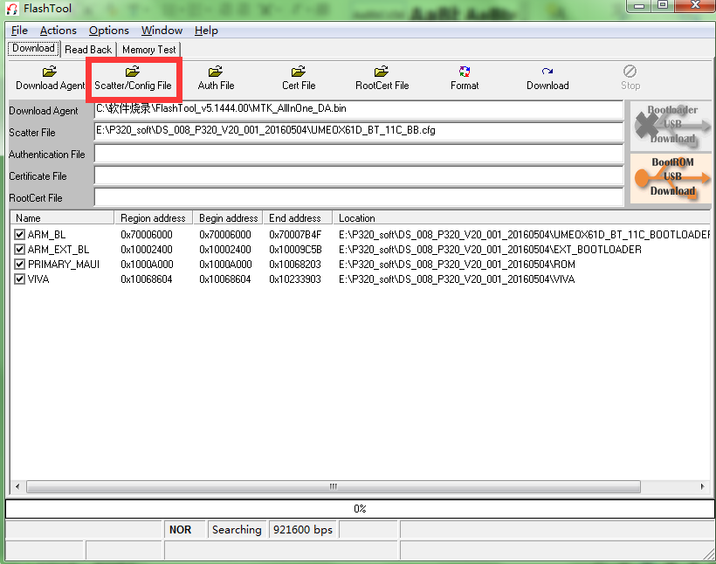
7. Choose the upgrade firmware, double click
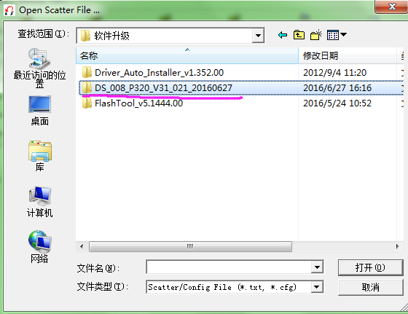
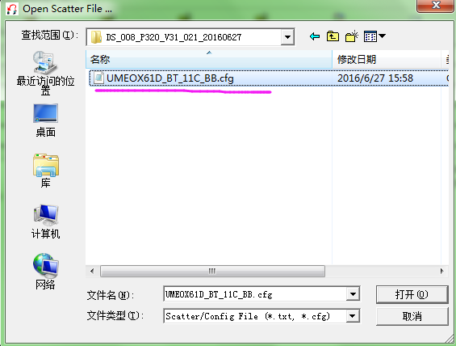

- Please confirm the tracker was shut down. And click Download. Then connect the tracker with computer by our usb cable. (Please note the sequence: Download→Connect device)

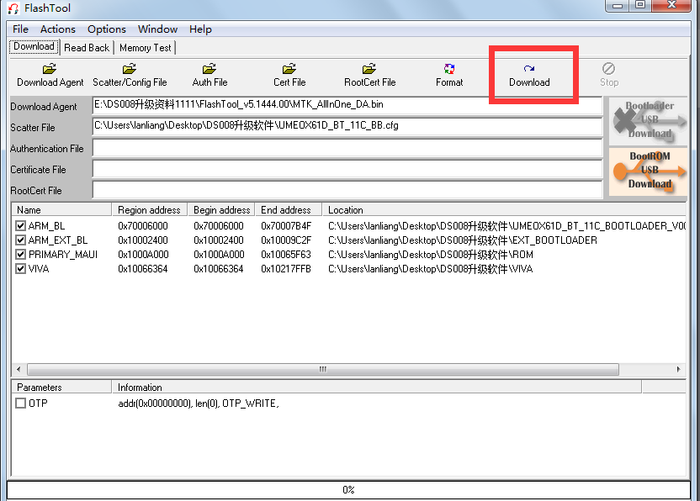

- device will start to upgrade. There will be a upgrade bar at the bottom, when 100%, means upgrade successful.
